
Gnome Street Gnome
GPIO
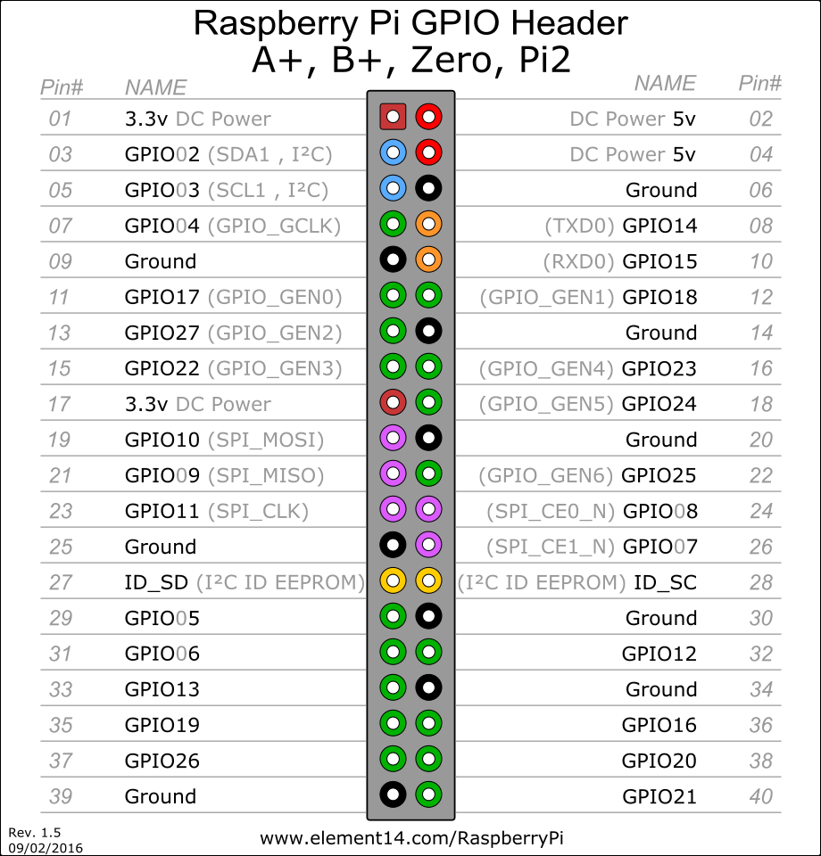
GPIO
General Purpose Input and Output is the name of the pins that can be used to control devices external to your computer. These are made available on a set of pins call the “Header”.
Watch out for the 2 different numbering methods, by pin and by number.

Output
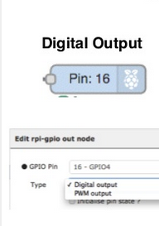
Digital (on/off) or PWM (pulsed for speed or intensity control)

Input
Pull ups are used to hold the signal at a known state when the input is not connected. e.g. for a switch
